**LAB FILE**

**SOFTWARE ENGINEERING**

**[IT301]**

**DEPARTMENT**

**OF**

**COMPUTER SCIENCE AND ENGINEERING**

**BACHELOR OF TECHNOLOGY IN**

**COMPUTER SCIENCE AND ENGINEERING**



Submitted To: Submitted By:

Dr. Sumit Kumar Siddharth Mehta

A235219144

6CSE-2Y

**CASE STUDY: AIR TRAFFIC CONTROL SYSTEM**

**AMITY SCHOOL OF ENGINEERING AND TECHNOLOGY**

**AMITY UNIVERSITY UTTAR PRADESH**

**NOIDA**

|  |  |  |  |  |  |  |  |  |
| --- | --- | --- | --- | --- | --- | --- | --- | --- |
| **Experiment No.** | **Category**  **of Assignment** | **Code** | **Name of Experiment** | **Date of Allotment of experiment** | **Date of Evaluation** | **Max**  **Marks** | **Marks obtained** | **Sign.**  **of Faculty** |
|  | **Mandatory Experiment** | **LR (0)** | **Formulating the problem statement for Air Traffic Control System.** | **7/01/2022** | **14/01/2022** | **1** |  |  |
|  | **Mandatory Experiment** |  | **Use Case Diagram Design For Air Traffic Control System** | **14/01/2022** | **21/01/2022** | **1** |  |  |
|  | **Mandatory Experiment** |  | **Creating Level-0 and Level-1 Data Flow Diagram For Air Traffic Control System** | **21/01/2022** | **28/01/2022** | **1** |  |  |
|  | **Mandatory Experiment** |  | **Creating E-R Diagram for Air traffic Control System** | **28/01/2022** | **4/02/2022** | **1** |  |  |
|  | **Mandatory Experiment** |  | **Creating Use Case Templates for Air Traffic Control System** | **4/02/2022** | **11/02/2022** | **1** |  |  |
|  | **Mandatory Experiment** |  | **Creating Sequence Diagrams for Air Traffic Control System** | **11/02/2022** | **18/02/2022** | **1** |  |  |
|  | **Mandatory Experiment** |  | **Creating A Class Diagram for Air Traffic Control System** | **04/03/2022** | **11/03/2022** | **1** |  |  |
|  | **Mandatory Experiment** |  | **Creating An Activity Diagram for Air Traffic Control System** | **11/03/2022** | **25/03/2022** | **1** |  |  |
|  | **Mandatory Experiment** |  | **Creating A State Chart Diagram for Air Traffic Control System** | **25/03/2022** | **1/04/2022** | **1** |  |  |
|  | **Mandatory Experiment** |  | **Creating A Component Diagram for Air Traffic Control System** | **1/04/2022** | **8/04/2022** | **1** |  |  |
|  | **Mandatory Experiment** |  | **Creating A Collaborative Diagram for Air traffic Control System** | **8/04/2022** | **22/04/2022** | **1** |  |  |
|  | **Mandatory Experiment** |  | **Creating A Deployment Diagram for Air Traffic Control System** | **22/04/2022** | **22/04/2022** | **1** |  |  |

**PROBLEM STATEMENT: Air Traffic Control System**

An Air Traffic Control system is a system that is needed to control the traffic in the air and prevent two aircraft from traversing the same path and colliding. It is a mechanism by which all planes within its airspace are monitored and given instructions, regarding path, position, speed etc. Every airport is equipped with an Air Traffic Control (ATC). This ATC is responsible for the plane to take off, accomplish the journey and land safely at the destination airport.

The existing ATC Formal Model has the following requirements:

* A *Static Topology* schema should be included with the following sub-parts:
  1. Connections
  2. Zones
  3. Airport
* A valid *Network State* with the specific Zone States should be included in the system with valid states.
* A set of *Aircrafts* flying within all the sectors of airspace is required with the following sub-parts:
  1. Source
  2. Destination
  3. Flight Data
* A set of *Controllers* controlling all the sectors of the airspace is needed with the following details:
  1. Sector
  2. Sector States
  3. Aircrafts
  4. Capacity

The proposed Air Traffic Control System is a modified and detailed version of increasing efficiency and automating the whole process. We propose a system where we automate the whole system and modify the requirements as follows:

* Structure and Reliability: placement of active working position equipment in a hardware room
* Flight Data Processing (FDP): automatic distribution of flight plans
* Radar Data Processing (RDP): automatic error correction in range and azimuth and filtering of inaccurate data
* Operator HMI: operator interface meets Eurocontrol requirements and unification for all types of working positions
* Automatic recording and storage with playback of Recorded Data
* Operational and technical monitoring of equipment and processes and common time synchronization;

**Use Case Diagram: Air Traffic Control System**

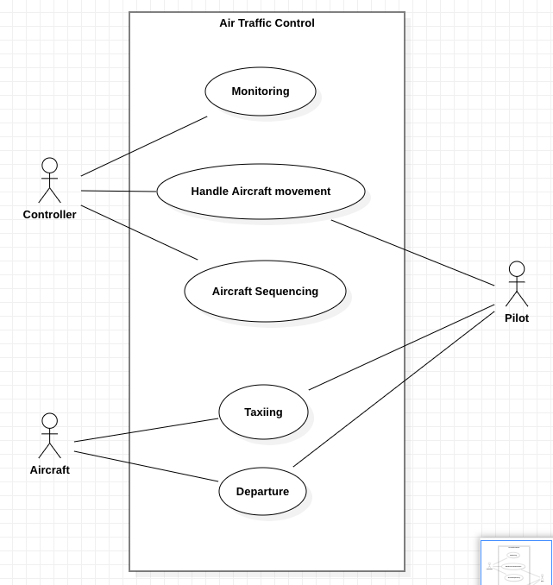

**Zero Level Data Flow Diagram: Air traffic Control System**

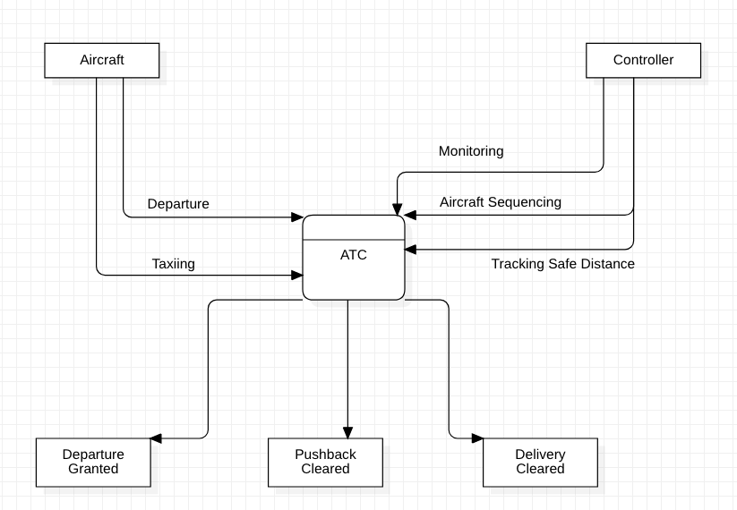

**ER Diagram: Air Traffic Control System**

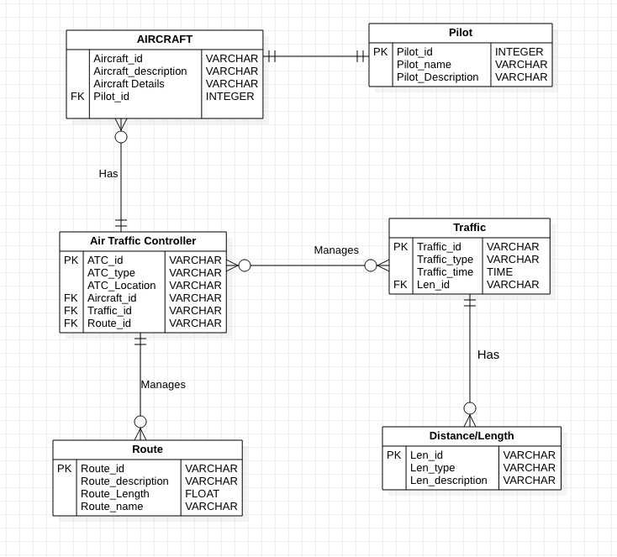

**Use Case Template (Login)**

1. **Introduction:**

This use case describes how a user logs in the Air Traffic Control System.

1. **Actors**
   * 1. Air Traffic Controller
     2. Aircraft Administrator
     3. Pilot
2. **Pre Conditions**

NONE

1. **Post Conditions:** If the use case is successful, the actor is logged into the ATC System. If not, the system state is unchanged.
2. **FLow of events**
   1. **Basic Flows:** This use case starts when the actor wishes to log into the ATC system
      1. System Requests the actor to enter their username and password
      2. The actor enters their password
      3. System validates the username and password, if found correct allow the actor to log into the system
   2. **Alternative Flows**
      1. If in the basic flow , the actor enters an invalid username or password, the system displays an error message and gives the actor two options either to return to the beginning of the basic flow or cancel this login, at which point the use case ends.
3. **Special Requirements**

NONE

1. **Use Case Relationship**

NONE

**Use Case Template (Flight Details)**

1. **Introduction:**

Allow Aircraft Administrators to maintain flight details.

This includes:

* Adding new flight details
* Changing the existing Flight Details
* Deleting the flight details

1. **Actors**
   * 1. Air Traffic Controller
     2. Aircraft Administrator
2. **Pre Conditions**

Aircraft admin should be logged into the ATC system before this use case begins.

1. **Post Conditions:** If the use case is successful, aircraft information is added/updated/deleted from the system. Otherwise the system state is unchanged.
2. **FLow of events**
   1. **Basic Flows:** Stars when the administrator wishes to add/modify/update/delete flight details.
      1. The admin specifies which function they would like to perform (Add/update/modify/delete)
      2. One of the sub flow will execute after the selection
         * Add a Flight
           1. The System Requests the Admin to enter:

* Flight Number
* Airline Name
* Departure Schedule
* Arrival Schedule
* Assigned Pilot Details
* Flight Status
* Aircraft Health
* Aircraft Fuel status
* Route
  1. **Alternative Flows**
     1. If in the basic flow , the actor enters an invalid username or password, the system displays an error message and gives the actor two options either to return to the beginning of the basic flow or cancel this login, at which point the use case ends.

1. **Special Requirements**

NONE

1. **Use Case Relationship**

NONE

**Sequence Diagram: Air Traffic Control System**

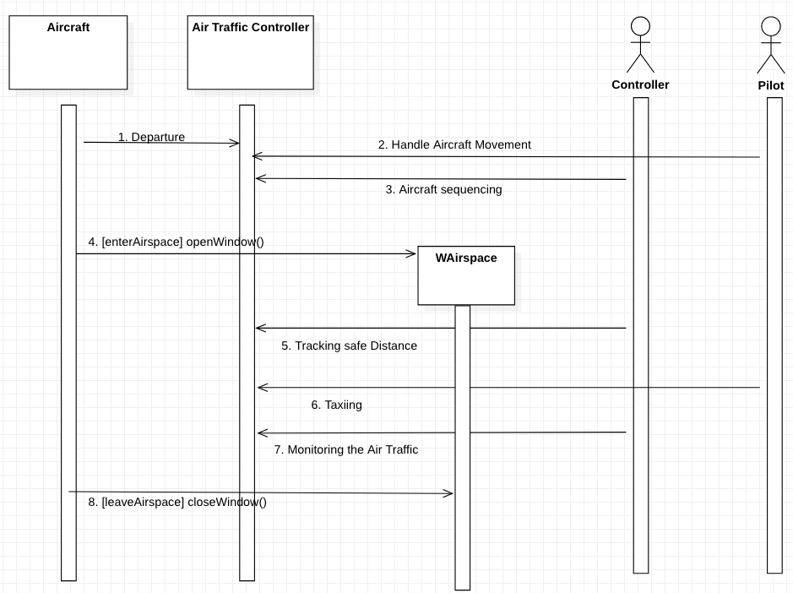

**Class Diagram: Air Traffic Control System**

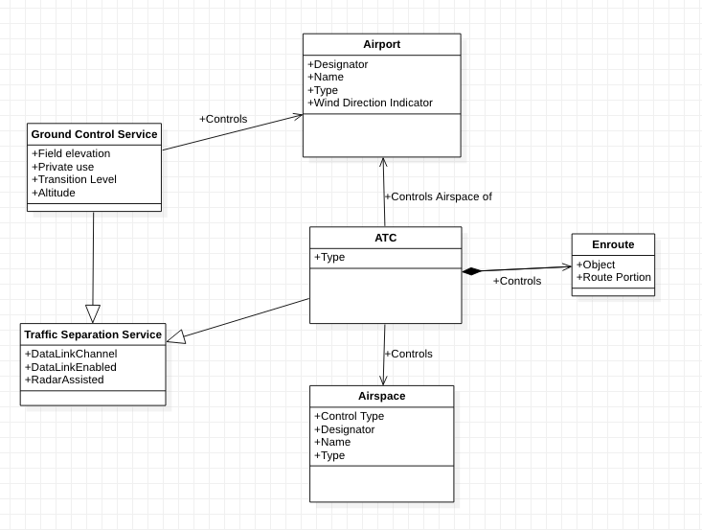

**Activity Diagram: Air Traffic Control System**

**(Admin)**

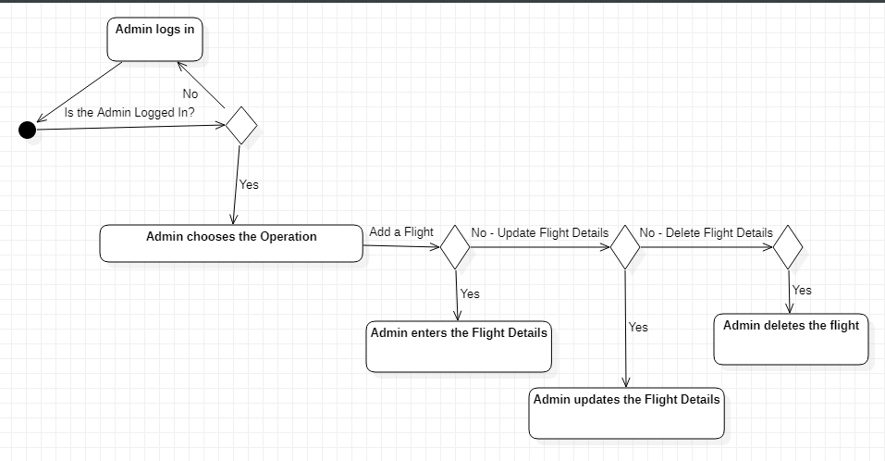

**State Chart Diagram: Air Traffic Control System**

**Component Diagram: Air Traffic Control System**

